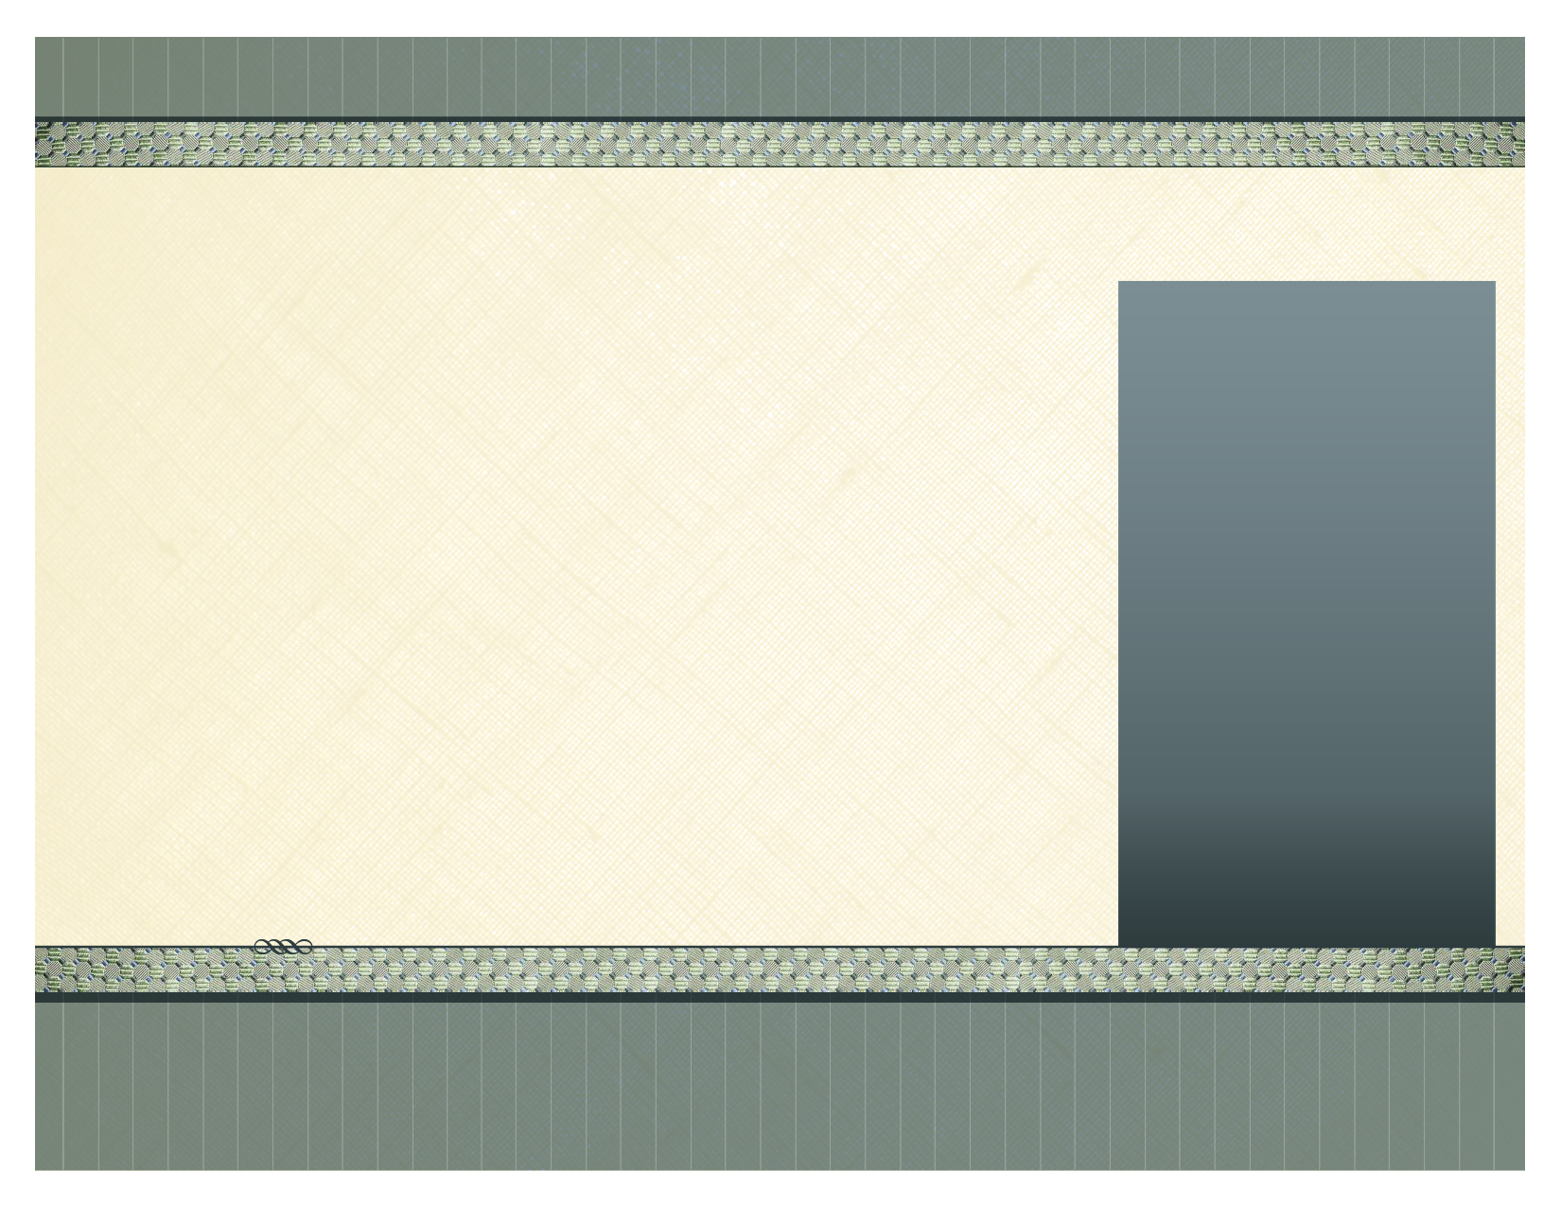
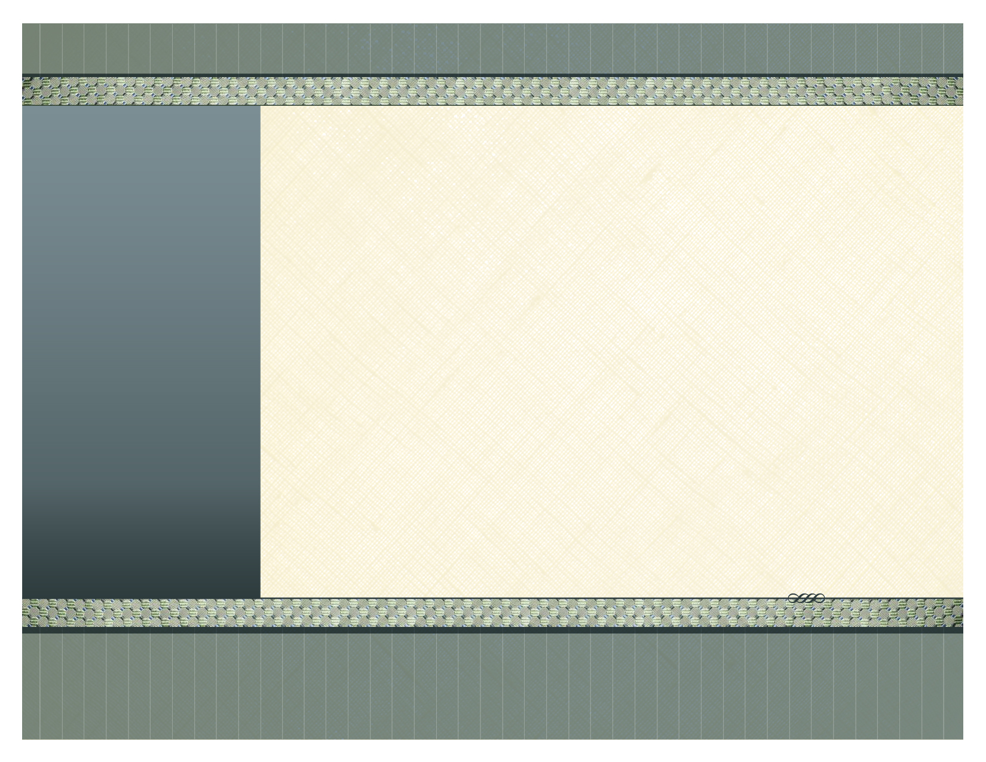
Price includes all importation, delivery to your property, installation, duty costs and VAT.

TERMS ...

50% down payment, and 50% when everything is delivered and fitted.

AIGA Tropical Living

The Living Room Master Bedroom
1 x Dining Table 160 x 80 cm (Ex) 1 x Banana Leaf Double Bed & Mattress
6 x Banana Leaf Dining Chairs 2 x Banana/Mahogany Bedside Tables
1 x Mahogany TV Sideboard 2 x Bedside Lamps
1 x Rounded Book Case 1 x Writing/Vanity Desk
1 x Banana Leaf Sofa 250 cm 1 x Banana Leaf Chair
1 x Banana Leaf Sofa 200 cm 1 x Banana Leaf Mirror 80 x 80
1 x Banana Leaf Coffee Table 1 x Floor Rug
1 x Banana Leaf Standing Lamp 1 x Long Banana Leaf Mirror 170 x 80
1 x Floor Rug 1 x Painting
2 x Paintings
1 x Nest of Side Tables Second Bedroom
1 x Table Lamp 2 x Banana Leaf Single Bed & Mattres s
2 x Decorative Table Bowls 2 x Banana Leaf Bedside Tables
2 x Paintings 2 x Bedside Lamps
1 x TV LCD 32” 1 x Long Banana Leaf Mirror 170 x 80
1 x DVD Player 1 x Floor Rug
1 x Painting
Third Bedroom
1 x Banana Leaf Double Bed & Mattress
2 x Banana/Mahogany Bedside Tables
2 x Bedside Lamps
1 x Long Banana Leaf Mirror 170 x 80
1 x Painting

Outdoor Furniture
1 x Teak Table 180 x 100 (Extendable)
6 x Teak Foldable Dining Chairs
5 x Sunbeds & Cushion
1 x Food & Drinks Trolley
1 x Teak Bench & Cushion
2 x Deck Chairs
1 x Coffee Table

Paradise Beach Resort – Furniture Inventory T3 (Accessories package also available – see Accessories Brochure)
Right of the main square, Santa Maria, Sal,
Tel: 00238 – 9183330 or 00238 - 9859318
www.aigacaboverde.com Facebook: Aigagroup Caboverde
AIGA Cabo Verde S.A.
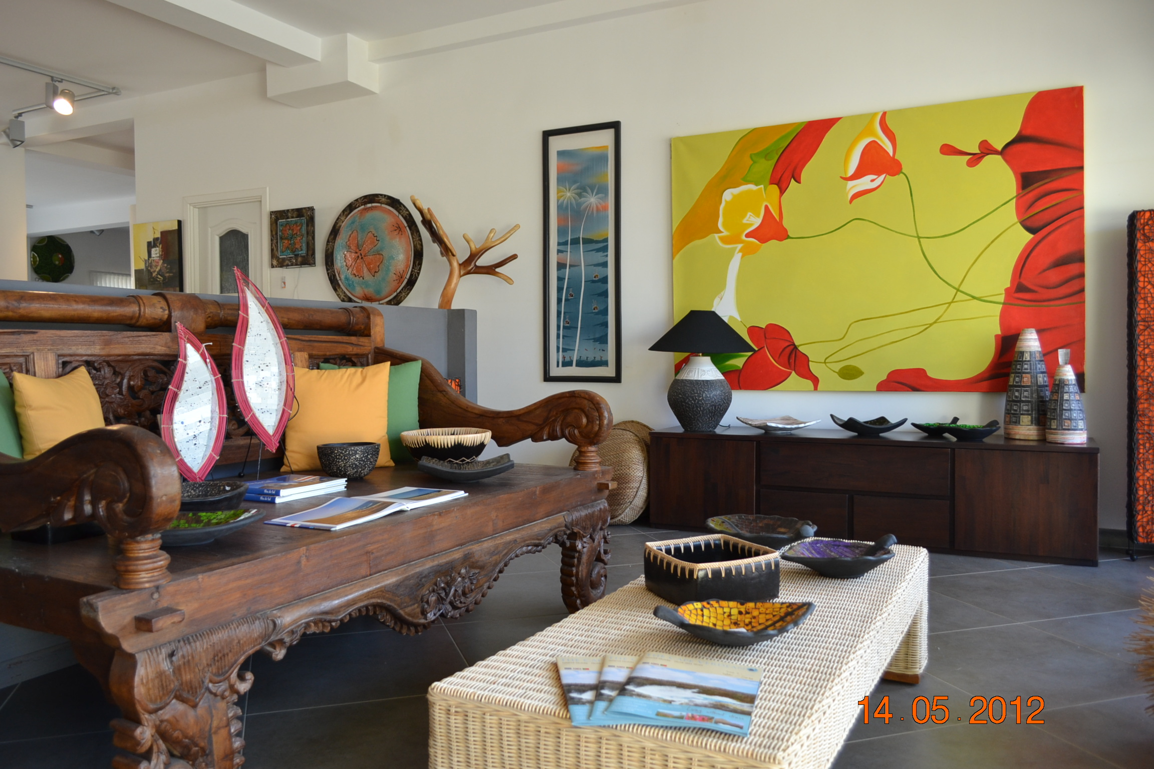

Master Bedroom Outdoor Furniture
1 x Banana Leaf Double Bed & Mattress 1 x Teak Folding Dining Table 140 x 80
2 x Banana/Mahogany Bedside Tables 6 x Teak Folding Chairs
2 x Bedside Lamps 2 x Teak Deck chairs with cushion
1 x Writing/Vanity Table 1 x Teak Bench with cushion
1 x Banana Leaf Chair
1 x Banana Leaf Mirror 80 x 80
1 x Floor Rug
1 x Long Banana Leaf Mirror 170 x 80

Second Bedroom
2 x Banana Leaf Single Beds & Mattress
2 x Banana Leaf Bedside Tables
2 x Bedside Lamps
1 x Long Banana Leaf Mirror 170 x 80
1 x Painting

The Living Room
1 x Extendable Dining Table 140 x 80 cm
6 x Banana Leaf Dining Chairs
1 x Mahogany TV Sideboard
1 x Rounded Book Case
1 x Banana Leaf Sofa 250 cm
1 x Banana Leaf Sofa 200 cm
1 x Banana Leaf Coffee Table
1 x Banana Leaf Standing Lamp
1 x Floor Rug
2 x Paintings
1 x Nest of Side Tables
1 x Table Lamp
2 x Decorative Table Bowls
2 x Paintings
1 x TV LCD 32”
1 x DVD Player

Paradise Beach Resort – Furniture Inventory T2

(ACCESSORIES PACKAGE ALSO AVAILABLE – See Accessories Brochure)

Price includes all importation, delivery to your property, installation, duty costs and VAT.

TERMS ...

50% down payment, and 50% when everything is delivered and fitted.
AIGA CABO VERDE S.A
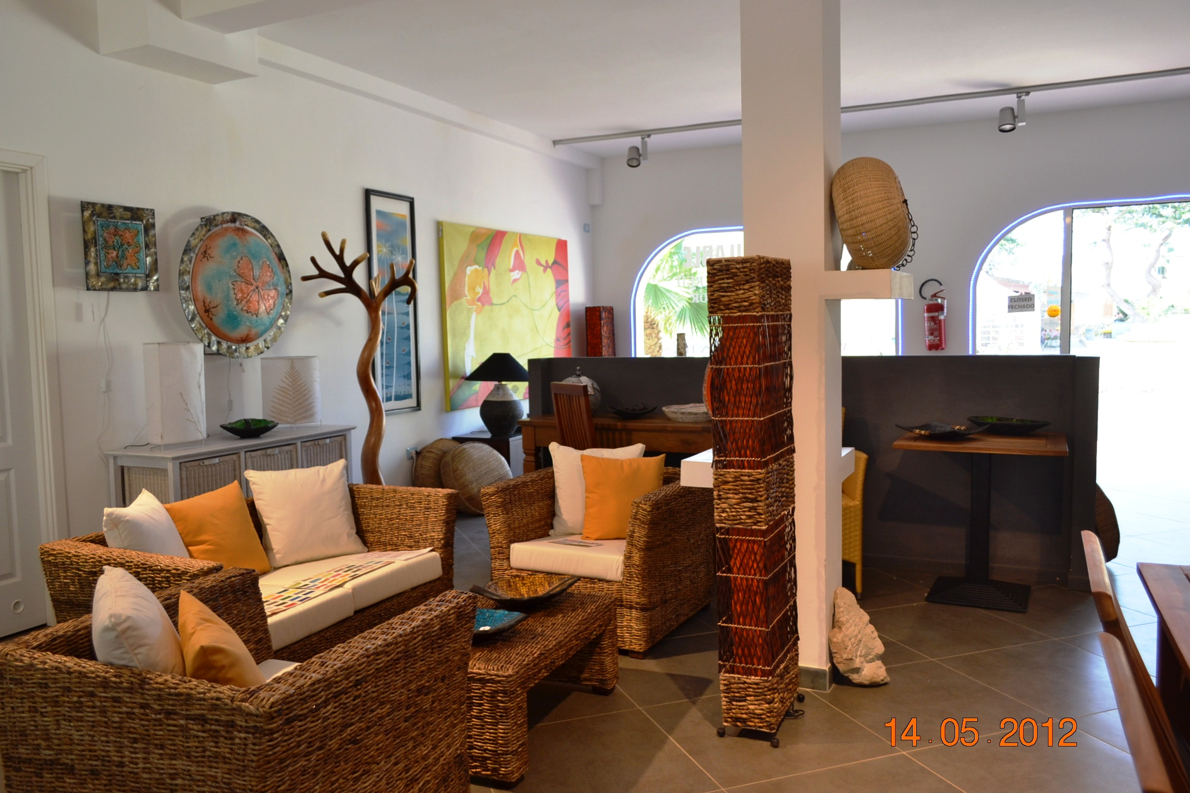

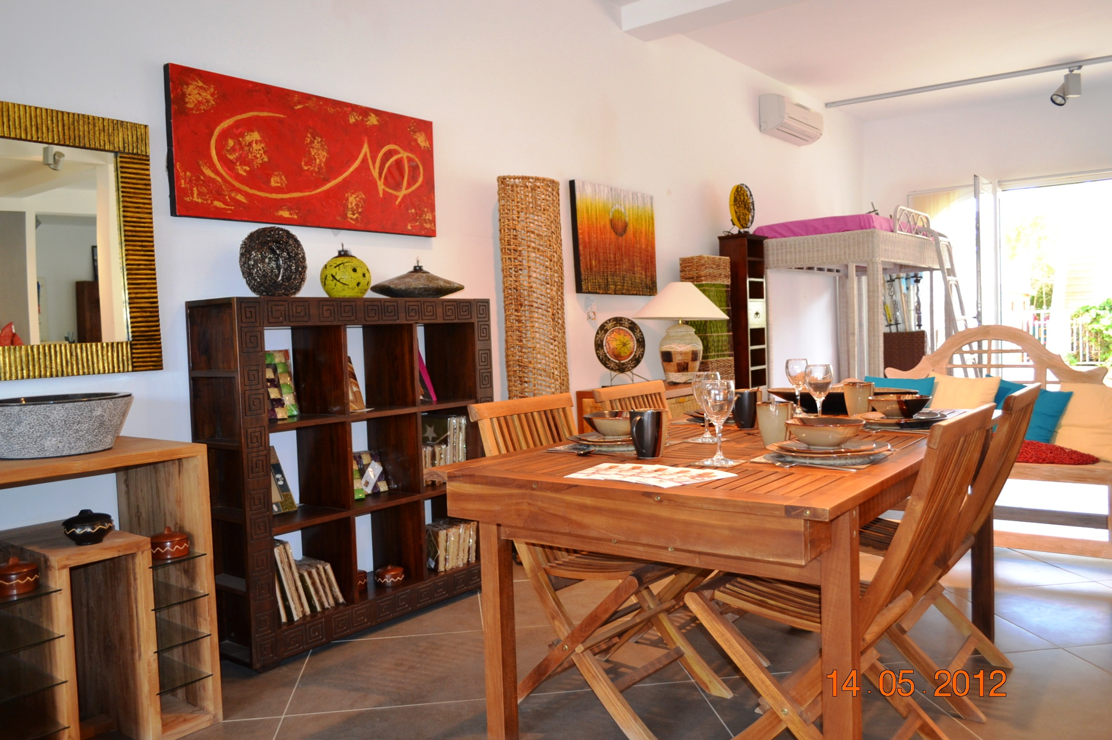

Right of the main square, Santa Maria, Sal
Tel: 00238 – 9183330 or 00238 - 9859318
www.aigacaboverde.com Facebook: Aigagroup Caboverde

Photos of AIGA showroom in Santa Maria, Sal

